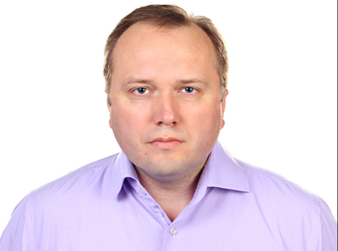
1. Personal information
Name | Lahun Yury
Address | 6/4 Popovicha lane, Grodno, 230024, Belarus
Phone number home | 810 375 152 64 50 78
Phone number mobile | +375 29 58 96 107
Marital status | Married
Date of birth | 25th February 1980
Nationality | Belarus
Email | lagunyury@gmail.com
2. Objective
To obtain employment in the field of health care that will allow me to use my ability to communicate with people and take advantage of my knowledge of English and to contribute professional skills to achieving your company's goals as a doctor.
3. Education
Grodno State Medical University (1997—2003)
4. Qualifications
04.01-07.04.2005 Refresher course "Oncology", Minsk, Belarus
28.08-26.10. 2006 Refresher course "Surgery", Minsk, Belarus
11.10-22.10.2008 Refresher course "Coloproctology and abdominal surgery"
10.06-21.06.2013 Refresher course "Diagnosis, treatment and prevention of malignant tumors", Vitebsk, Belarus
20.01-31.01.2014 Refresher course "Oncosurgery", Vitebsk, Belarus
12.01-23.01.2015 Refresher course "Actual aspects of oncology", Minsk, Belarus
5. Work experience
Grodno State Medical University, assistant Professor of the Department of Oncology (2012-2022);
My responsibilities include: teaching students, including foreign ones in English, сuration and treatment of patients with breast pathology in Department of Breast Oncology (Grodno regional hospital).
Worked as a surgeon and oncologist in a Mosty Central District Hospital (the Grodno region) in 2004-2012.
Beginning as an intern Volkovysk Central District Hospital (the Grodno region) in 2003-2004.
6. Personal qualities
Dependable
7. Special skills
Language skills : Native Belarus, Russian; Fluent English, working knowledge of Polish (Basic knowledge)
Driving License (Category B)
Computer literacy (Microsoft Office)
8. Memberships
Belarusian Society of Oncologists
Belarusian Society of Doctors
Polish Association of Doctors in Belarus
9. References
Available upon request

